Mid Term Exam
Fall Semester: 2025

Paper Information
Course Title: | Algorithm and Complexity Analysis | Course Code: | CSC-379-01 / CSC-575-01
Exam Duration: |  | Number of Pages: (including cover page) | 8
Exam Day/Date: | 10/28/2025 | Exam Time: | 10:30 AM

Student Details
Student Name: |  | Student ID:
CRN: |  | Instructor:
Deadline of submission: | 10/30/2025 | Time: | 12:30 PM

Exam Instructions
- Fill the above ‘Student Details’ section carefully and complete.

- Cheating is strictly prohibited and action will be taken.
Marking Scheme |  |  |  |  | Learning Outcomes Achievement
Question No. |  | Actual Score / Max. Score |  |  | Learning Outcome | Question  # | Student’s Achievement
Q1 |  | /20
Q2 |  | /20
Q3 |  | /60
Total Score: |  | / 100

- Color with red ONE correct answer (letter) for each of the following MCQs in the table below.

Actual Score

--

1 | 2 | 3 | 4 | 5 | 6 | 7 | 8 | 9 | 10
a | a | a | a | a | a | a | a | a | a
b | b | b | b | b | b | b | b | b | b
c | c | c | c | c | c | c | c | c | c
d | d | d | d | d | d | d | d | d | d

- The performance of an algorithm is most closely related to what?
- The total number of element visits
- The total number of elements
- The type of elements
- The number of lines of code in the method

- While searching in a sorted array which algorithm performs better
- Linear Search
- Sequential Search
- Both Binary and Sequential take same time
- Binary Search

- _______is a good data structure to use for storing things that need to be kept in order, such as a set of documents waiting to be printed on a network printer.
  - A queue
  - an array
  - Tree
  - Graph
- _______________ consists of a number of nodes, each of which has a reference to the next node.
  - A linked list.
  - an array
  - Tree
  - Graph

- Which one of the following statements is a valid declaration of an array named names of three elements?
  - String names {} = new String[3];
  - String [] names = new String [3];
  - String names [3] = new String;
  - String names[length] = new String();
- Insertion of an element at the middle of a linked list requires the modification of how many pointers?
  - 1
  - 2
  - 3
  - 4
- Process of inserting an element in stack is called ____________
  - Push
  - Create
  - Evaluation
  - Pop

- Process of removing an element from stack is called __________
  - Pop
  - Create
  - Push
  - Evaluation

- Queue follows __________ which is a form of access to add and remove nodes from a queue.
  - FIFO, First In First Out.
  - LIFO, Last In First Out
  - Both a and b
  - None of these
- Which form of access is used to add or remove nodes from a stack?
  - LIFO, Last In First Out
  - FIFO, First In First Out
  - Both A and B
  - None of these
[20 Marks]

- For each question, color True (T) or False (F) as appropriate.

Actual Score

--

1 | Queue add items to one end of the queue which is called a head | T | F
2. | Stack allows insertion and removal of elements only at one end  which is called the top of the stack. | T | F
3 | Data structures provide a means of managing large amounts of data, enabling efficient searching, sorting, insertion, and deletion of data. | T | F
4 | Computer using the queue for print jobs. | T | F
5 | Stacks are different than linked lists or arrays because we can’t know the contents of the stack without removing the top element every time | T | F
6 | An array is a data structure that contains a group of elements of the same data type. | T | F
7. | A list is an ordered set of data. It is often used to store objects that are to be processed sequentially. | T | F
8. | Data enters the queue at one end and leaves at the other. | T | F
9. | Character is an example of a primitive data structure. | T | F
10. | A linked list is an example of a primitive data structure. | T | F

[20 Marks]

Actual Score

--

A)
Write a java program to obtain the following statements:

- Create a linkedlist named "Books" with these elements: " Java ", " DB " "Python", and “Network”.
- Add new element "Security" after the element "DB".
- Display all element of the list.
Note: Please use the in-built Java library class”LinkedList” and interface“ListIterator”

//Program

[20 Marks]

B) What is the output of the following program:

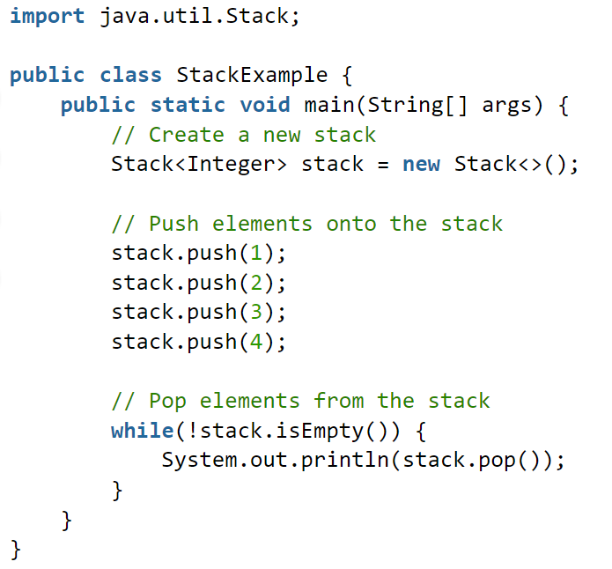

Output :

[20 Marks]
~~~~~~~~~~~~~~~~~~~~~~~~~~~~~~

[20 Marks]
~~~~~~~~~~~~~~~~~~~~~~~~~~~~~~

End of Examination… Good Luck!

